# REPORT ON STUDENT INDUSTRIAL WORK EXPERIENCE SCHEME

**(SIWES) TRAINING PROGRAMME**

**UNDERTAKEN AT**



**NATIONAL SPACE RESEARCH AND DEVELOPMENT AGENCY,**

**FEDERAL MINISTRY OF SCIENCE AND TECHNOLOGY, ABUJA.**

**BY**

**ALUKO OLAWALE WILLIAMS**

# 2014/1/53310PG

**FROM: MAY 28TH, 2018 – NOVEMBER 16TH,2018**

**SUBMITTED TO THE**

**DEPARTMENT OF GEOGRAPHY**

**SCHOOL OF PHYSICAL SCIENCES**

**FEDERAL UNIVERSITY OF TECHNOLOGY MINNA, NIGER STATE.**

**DEDICATION**

I dedicate this industrial report to God for His sustaining grace.

**ACKNOWLEDGEMENT**

My sincere thanks goes Dr Halilu Shaba (the director, Strategic Space Application) for giving me the opportunity to intern in NASRDA and DrRakiya, head of .

I also want to express my appreciation to my industrial based supervisor: Mr. Ajayi, a very big thanks to Mr Caleb Odiji my industrial based instructor, Mr Tola Adediji andother SSA Staffs for their intellectual support during our work together.

Not forgetting my IT colleagues and NYSC Members. My sincere appreciation also goes to everyone that has been by me all this while.

**TABLE OF CONTENTS**

**TITLE PAGE** 1

**DEDICATION** 2

**ACKNOWLEDGEMENT** 3

**LIST OF FIGURES** 6

**CHAPTER ONE**

1.0 INTRODUCTION 7

1.1 THE INDUSRIAL TRAINING FUND (ITF) 7

1.1.1 MISSION OF THE ITF 8

1.1.2 VISION OF THE ITF 8

1.2 HISTORICAL BACKGROUND OF SIWES 8

1.2.1 AIM AND OBJECTIVES OF SIWES 9

**CHAPTER TWO**

2.0 NATIONAL SPACE RESEARCH AND DEVELOPMENT 10

AGENCY

2.1 LOCATION AND HISTORY OF NASRDA 10

2.2 DEPARTMENTS AND UNITS OF ESTABLISHMENTS 12

2.2.1 DEPARTMENT OF STRATEGIC SPACE APPLICATIONS 14

2.3 SATELLITE AND SPACE DEBRIS 15

2.3.1 NIGERIASAT-1 15

2.3.2 NIGCOMSAT-1 16

2.3.3 NIGERIASAT-2 17

2.3.4 NIGERIASAT-X 18

**CHAPTER THREE**

3.0 RELEVANCE OF REMOTE SENSING AND GIS IN 20

3.1 REMOTE SENSING 20

3.2 GEOGRAPHICAL INFORMATION SYSTEM (GIS) 20

3.3 GIS IN URBAN MAPPING 21

3.4 REMOTE SENSING IN URBAN MAPPING 21

3.5 OVERVIEW OF POTENTIAL AREAS OF REMOTE SENSING 21

AND GIS DATA UTILIZATION IN NIGERIA

**CHAPTER FOUR**

4.0 DISCUSSION AND ANALYSIS OF EXPERIENCE 26

ACQUIRED DURING MY SIWES PROGRAMME

4.1 ArcGIS 10.3 26

4.2 ERDAS IMAGINE 2014 27

4.3 GOOGLE EARTH PRO 28

4.4 ENVI RS SOFTWARE 29

**CHAPTER FIVE**

5.0 CONCLUSION 32

5.1 RECOMMENDATION 32

REFENCES 34

**LIST OF FIGURES**

FIG 2.1 NARSDA ENTRENCE GATE

FIG 2.2 ORGANOGRAM OF NARSDA

FIG 2.3: FRONT VIEW OF STRATEGIC SPACE APPLICATION, ABUJA

FIG 2.4 MODEL OF NIGERIASAT-1

FIG 2.5 NIGERIASAT-2 CARRYING CRAFT

FIG 2.6: NIGERIASAT-X

FIG 4.0: LAND USE/LAND COVER MAP OF ABUJA AMAC 2016

FIG 4.1: POPULATION DENSITY MAP

**CHAPTER ONE**

## 1.0 INTRODUCTION

Education is the process of training and given of instructions to children and young people in schools, colleges and tertiary institutions. It is designed for knowledge acquisition and the development of skills. Knowledge involves skills acquired through experience.

Experience is the process of gaining knowledge or skill over a period of time through sight and practical, rather than through studying alone. This definition proves beyond reasonable doubt that acquisition of knowledge is not limited to schools. In other words, it is necessary for students undergoing professional course to take a particular time off their school to relevant organizations to acquire more knowledge.

However, it is in line with this that the Industrial Training Fund (ITF) a government parastatal was established to improve the quality and standard of education in Nigeria. The Industrial Training Fund (ITF) came up with a programme called Student Industrial Work Experience Scheme (SIWES) in other to make sure that students move out of their schools to have practical experience of theories being taught in schools. The importance of this programme cannot be over emphasized as it exposes students to their profession ethics.

### 1.1 The Industrial Training Fund (ITF)

The Industrial Training Fund, a government parastatal was therefore established based on the provision of the decree No 47 of 1971 during the second National Development Plan (1970-1974). This was during the military regime of General Yakubu Gowon in the attempt of the federal government to promote and encourage acquisition of skills in industries. It is also to see to technical development and self-reliance in man power. The body extends this motive to tertiary institution by developing a program tagged student industrial work experience scheme (SIWES) mostly referred to as Industrial Training (IT).

This is to make sure that students were able to have technical experience concerning their respective field of study. This coupled with theoretical knowledge produce a well-educated acquired student. The Industrial Training Fund (ITF) in other to achieve this purpose offers some grant reimbursement for training experience to participants of the training. This is to encourage people to take part in advisory service to industries and various training workshop and courses.

The development of Student Industrial Work Experience Scheme (SIWES) can be traced to Cincinnati in USA where collaboration evolved between the universities and industries for providing students practical experiences in 1906. This idea was however embraced when Federal Military Government set machineries in motion by promulgating the Industrial Training Fund.

Furthermore, the essence of this program SIWES cannot be over- emphasis when it comes to the field of practice like Geography and Regional Planning where the need for practical experience is most needed to compare vis-a-vis the classroom theories and experience in the professional field.

#### 1.1.1 Mission of the ITF

To set and control standards of excellence and effectiveness in, and offer direct training of professionals, technicians, technologists and entrepreneurs using best-ofbreed training techniques and modern technology as well as highly motivated, competent staff for rapid industrialization and economic development of Nigeria.

#### 1.1.2 Vision of ITF

To be the foremost human resource development organization in providing dynamic, need-based and quality driven intervention for industrial skills training and development in Nigeria and the rest of Africa.

### 1.2 Historical Background of SIWES

SIWES is a short form of the word Students Industrial Work Experience Scheme. It was established by the Industrial Training Fund (ITF) in 1973. Industrial Training Fund (ITF) is a Federal Government establishment established through the enactment of Decree 47 of 1971 by the then military head of state, Rtd. General Yakubu Gowon. The prepossessing fact behind its establishment was to promote and encourage the acquisition of skills in commerce and industry with the view of generating a pool of indigenous skilled manpower required in commercial and industrial sectors of the national economy. This was as a result of failed adequate practical skilled labour preparatory for employment in industries and establishment by Nigerian graduates of tertiary institutions.

In addition, note the Industrial Training Fund (ITF) will design a co-operative medium with the industry to help students of tertiary institutions receive training in industry that are relevant to their study. The Fund is expected to support the programme by contributing to the allowance payable to students. The Scheme was expected amongst other things to provide the students with necessary and basic practical knowledge so as to expose their students in question on different industrial knowledge his/her professional course demands. The National University Commission (NUC) places utmost importance on the Students Industrial Work Experience Scheme (SIWES) programme, which is in partial fulfilment of the requirement for the award of Bachelor in Geography and Regional Planning (B.GRP) Degree in the Department of Geography and Regional Planning and to professional courses in Delta State University, Abraka and other higher institutions of higher learning. In Nigeria, Industrial Training Fund has 27 offices throughout the federation that oversees industrial training (IT) student in different parts of the country.

#### 1.2.1 AIM AND OBJECTIVES OF SIWES

The aim of this Student Industrial Work Experience Scheme (SIWES) is to expose students to the practical aspect of their discipline and also to raise the student technical know-how in tackling problems associated with the professions, combining both academic and practical competence with a view to achieving the desired result. The Industrial Training Fund (ITF) in other to reach out to student came-up with the Student Industrial Work Experience Scheme (SIWES), the scheme is to achieve the following objectives:

1. To enhance the transition from school to the world of work easier and enable students use it as contacts for employment later.
2. To expose students to techniques in handling equipment and machineries that may not be available for students in the workshop or studios
3. To promote and encourage the acquisition of the much-needed skills in industries
4. To allow the students the chances to be practically oriented and have work methods that would not be taught in the institutions.
5. To assess the suitability of the occupation She/he has chosen and the level of interest of students.
6. To give the students opportunity to apply their theoretical knowledge in real work situation therefore bringing the gap between college work and actual practice.
7. To enlist and strengthen employer’s involvement in the entire educational process of preparing the students for employment in industries.

**CHAPTER TWO**

## 2.0 NATIONAL SPACE RESEARCH AND DEVELOPMENT AGENCY

National Space Research and Development Agency is a Government parastatal body that focuses on national development through the use of Space technology. NASRDA has a large bounded space of hectares of land with the entrance gate at the Musa Yaradua express way at Lugbe; it’s some kilometre away from the central area of Abuja city close to the National Stadium.

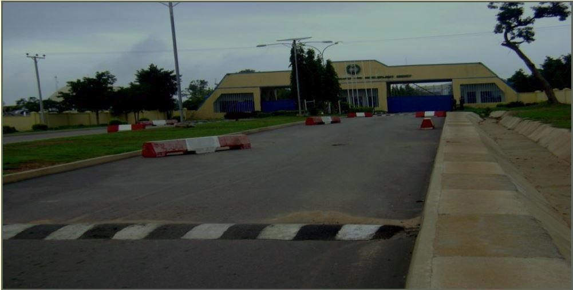

**Figure 2.1: NASRDA Entrance Gate.**

## 2.1 LOCATION AND HISTORY OF NASRDA

National Space Research and Development Agency is located in Abuja the Federal Capital Territory which is located in Lugbe, some kilometres away from the central area in the Guinea Savannah region of the middle belt. It is situated between Latitude 80.2̊ 5 ̎̍ .and 90.2̊ 5̍ ̎. North of the Equator and Longitude 6̊ 45 ̎̍ .W and 70̊ 45̍ ̎.E of the Greenwich Meridian.

In April 1987, an Inter-Ministerial Committee drew up a programme for the establishment of the National Remote Sensing Centre, Jos. In the same month (April, 1987), a two-man committee was set up at the request of the Nigerian Government to advise on the user needs and other aspects of Space Technology, strongly advised in their report that Nigeria should set up among other things machineries/infrastructures for the development of Space Science and technology in the country.

Consequent upon this, the Federal Ministry of Science and Technology (FMST) constituted a National Committee on Space Applications with membership drawn from Universities, Research Institutes, Armed Forces and relevant Ministries to advise government on modalities for the implementation and harmonization of Space Science and Technology Programmes in the country.

In 1993, the National Agency for Science and Engineering Infrastructure (NASENI) took over from the FMST and established a Directorate of Science, with a mandate that specifically include Space Science and Technology. NASENI later constituted a nine-man committee of experts. that produced a draft on National Space Science and Technology Policy after extensive consultation with experts both at home and in diaspora. Sequel to this, the National Centre for Remote Sensing, Jos took off in 1996 as the first Centre among the Centres proposed within the policy framework.

On 5th May, 1999 the Federal Government of Nigeria, led by former President Olusegun Obasanjo (GCFR), established the National Space Research and Development Agency (NASRDA). NASRDA was given a mandate to pursue the development and application of Space Science and Technology for the socioeconomic benefits of the nation. Consequently, the Federal Government approved the National Space Policy and Programmes in May, 2001, thus creating an enabling en+vironment for the actualization of the nation’s space agenda.

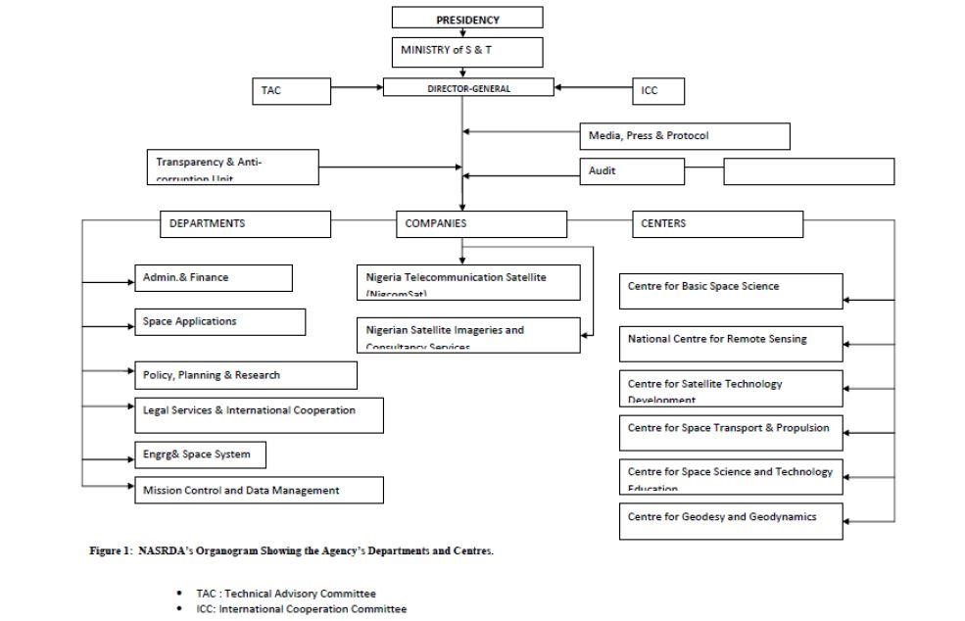

**Figure 2.2: ORGANOGRAM OF NASRDA.**

### 2.1.1 Objectives of establishment

The key objectives and focus of the National Space Policy and Programme are highlighted as follows:

* The study of basic space science in order to lay the foundation for deriving maximum benefits from the nations participation in the space enterprise. To provide the understanding of how the universe works and what its impact is on the world.
* The attainment of space capabilities through research and rigorous education, engineering development, design and manufacture, particularly of instrument, rocketry and small satellites as well as in satellite data acquisition, processing and analysis and use in resources, ecological and disaster management.
* The establishment of a national Earth observation station for remote sensing and meteorology. Such an infrastructure will enhance the indigenous ability to adopt, modify and create new techniques for national resources inventories, monitoring, evaluation and management.
* The provision of efficient, reliable and adequate telecommunications services in Nigeria in order to enhance the growth of the industrial, commercial and administrative sectors of the economy.
* Development of Satellite Meteorology to study the atmosphere for weather sciences with implication on the effective management of our environment and resources. • The establishment of Defence Space Command (DSC) comprising the representatives of the defence, intelligence, security and law enforcement services that should be reporting to the National Space Council. The DSC, in collaboration with NASRDA shall develop necessary Space Science and Technology (SST) programme that will address the defence and security needs of Nigeria.
* Establishment of observatory sites with state-of-the-art equipment such as the Seismograph, Global Position System (GPS), Satellite Laser Ranging (SLR) and Very Long Baseline Interferometry (VLBI) as part of global observatories for monitoring of Earth movement.

## 2.2 DEPARTMENT AND UNIT OF ESTABLISHMENT (SSA)

The department of Strategic Space Applications came into existence in 2001. Space Application is central and critical to successes recorded by any space agency in the world. It is a department which ensures that spin-offs from space expeditions get to the common man through various applications projects that touch on the lives of the citizens. The use of data/information from Earth Observation and other relevant satellites play a vital role in the collection and dissemination of information, in a very timely manner. Space derived data provides a very powerful planning tool that will significantly improve the quality, efficiently and technical depth of decision making in the allocation of resources, environmental management, land use, agriculture, mineral resources, urban planning, water resources etc. The Department of Space Applications is positioned to embark on projects and provide services that will utilize space data to address socio-economic problems.

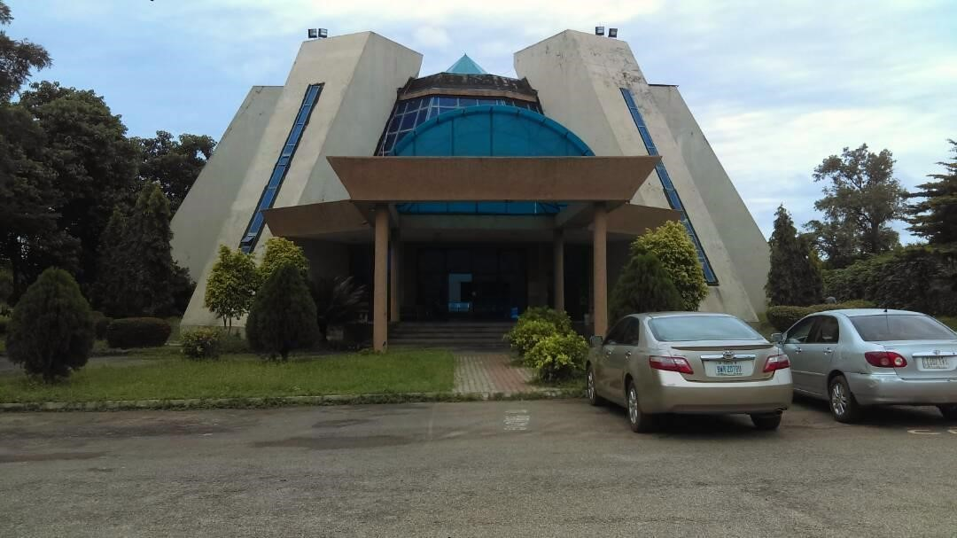

**Figure 2.3: Front view of Strategic Space Application, Abuja** **Mandate:**

1. Promote and consolidate all space applications and space applications related activities through appropriate research and development for the purpose of optimizing resources and making the space programmes to have more impact on Nigeria’s socioeconomic development.
2. Promote space applications and space applications related research and development for the purpose of managing and protecting the environment, hazards and disaster management.
3. Supervise the activities of centres that that are assigned to the department, particularly, those related to the functions of Space Applications Department such as NCRS, Jos, Plateau state and CGG, Toro, Bauchi State.
4. Provide expertise for the Agency’s participation in international organizations on Earth Observation and the activities of the Committee on the Peaceful Uses of Outer Space.
5. Develop appropriate space applications software tailored to space applications needs.
6. Carry out other activities that are necessary or expedient for the function of the Agency, including activities that may be assigned to the department from time to time by the DG/CE, e.g. collaborations with Geo-Apps Nigeria Ltd to carryout consultancy projects.

**2.2.1 Departments under Strategic Space Application (SSA) Divisions of the Department:**

The Department is divided into four main Divisions which include:

* Cadastral Mapping and Urban Space Applications (CMUSA)
* Climate Change Management (CCM)
* Natural Resources Management (NRM)
* Hazards and Environmental Management (HEM)

**a. Cadastral Mapping and Urban Space Applications (CMUSA) Division** I. Mapping/planning population survey and census enumeration areas.

1. Rural and urban growth mapping and monitoring.
2. Monitoring land use /land cover dynamics.

## b. Climate Change Modelling (CCM) Division

1. Poverty alleviations and food security through management of Nigeria natural resources.
2. Understanding the earth and its environment from space; for national development.
3. Space based integrated climatic change research in Nigeria.

**c. Natural Resources Management (NRM) Division** I. Integrated sustainable resources management.

1. Space applications in poverty mapping.
2. Space applications in facility mapping.
3. Development of High Resolution Digital Terrain Model (DTM).

**d. Hazards and Environmental Management (HEM) Division** I. Implementation of UN- SPIDER.

1. West African Regional Integrated Coastal Area Management (WARICAM).

. West African Regional Integrated Coastal Area Management Organization (WARICAMO).

. Space based sea level rise scenario modelling.

1. Remote Sensing and GIS for vector diseases mapping.
2. Development of space based model for flood disaster and early warning in Nigeria.

## 2.3 SATELLITE AND SPACE DEBRIS

### 2.3.1 NigeriaSat-1

The NigeriaSat-1 satellite is Nigerian’s first satellite in Space. It was launched on Saturday, September 27 2003 at 10:11am Russian time (7:11am Nigerian time) from the Plesetsk Cosmo Rome space centre in Siberia. The 94kg NigeriaSat-1 satellite was launched alongside five other satellites; 100kg UK-DMC of the United Kingdom, 100kg KAISTSAT-4 of South Korea, 100kg BilSat-1 of Turkey, 64kg Mozhayets, a Russian satellite for the training of Russian Military Academy students and 37kg Larets (small box), also a Russian satellite. The NigeriaSat-1 is one of the Disaster Monitoring Constellation (DMC) satellites. Nigeria as a nation is a member of the seven DMC countries with other members being Algeria, China, Thailand, Turkey, United Kingdom, and Vietnam. The seven DMC countries share the satellite technology in Lower Elliptical Orbit (LEO) for disaster monitoring and remote sensing. Algeria was the first to launch her DMC satellite- Alsat-1 on November 28, 2002.

The first DMC countries meeting was held in Surrey in the United Kingdom. The second DMC meeting was held in Algeria on the 22nd and 23rd of April 2002 in Algiers. Nigeria hosted the third DMC meeting in Abuja on April 3rd and 4th 2003.

NigeriaSat-1 was launched on the Russian COSMOS 3-M rocket (11K65M), model P1LC-132/1. The ground station for NigeriaSat-1 is permanently at NASRDA Headquarters, Abuja, Nigeria. The ground station made first contact with NigeriaSat-1 at about 10:25 am (Nigerian time), about three hours after launch. NigeriaSat-1 makes a pass at the station four times a day between 9:00am – 11:00am and 9:30pm – 12pm, with five days’ revisit time. Each pass near the ground station lasts an average of 11.5 minutes. It takes Nigeria’s pictures between 9:30am and 10:30am daily with a downlink at 8Mbps in S-band, VHF Q PSK with its 2 patch antennas within the reception of ground station. NigeriaSat-1 ground coverage on a single image is 600 × 570km, which is an equivalent of 9 US Landsat TM. NigeriaSat-1 has a strong potential for Normalized Differential Vegetable Index (NDVI) and an advantage of data availability in various formats at affordable cost even in local currency.

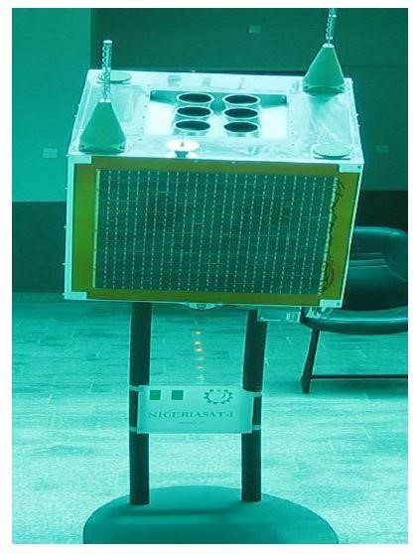

## Figure 2.4: Model of NigeriaSat-1

### 2.3.2 NigcomSat-1

NigComSat-1 was a Nigerian communication satellite. The initial contract to build the satellite was signed in 2004. It became the first African geosynchronous communication satellite, when it was launched at 16:01 GMT on 13 May 2007, aboard a Chinese Long March 3B carrier rocket, from the Xichang Satellite Launch Centre in China. The spacecraft was operated by NigComSat and the Nigerian Space Agency, NASRDA.

Since the advent of the commercial uses of satellite in the 1960s with the launching of the “early bird”, countries in Africa have been utilizing satellite communication in the traditional manner using facilities provided mainly by INTELSAT. Much has changed with the launching of nigcomsat-1 on the 14th may 2007. It has changed the face of satellite communication in Africa and indeed was the beginning of good things and technological advancement in Africa. As Nigeria leads others will follow.

Before the launch of Nigerian telecommunication satellite- NigcomSat-1, Nigerian television companies, telecom companies, and ministries employ the use of foreign satellites transponders to transmit their programs. The foreign telecom companies used are Intelsat, PanamSat and Eutelsat and the national users are Nigerian Television Authority (NTA), the Nigerian Telecommunication Ltd. (NITEL), Nigerian Aviation Ministry (NAM) and the Nigerian Defence Ministry (NDM).

NTA, Nigerian first and largest network with the largest network in Africa, uses a whole transponder of 103/105 for zonal beam in the south-eastern zone on the GEO satellite of Intelsat 907 for their network broadcasts. This costs them USD1m per month. The launch of NigcomSat-1 saves NTA a sum of USD12m per annum.

On November 11, 2008, NigComSat-1 failed in orbit after running out of power due to an anomaly in its solar array.

### 2.3.3 NigeriaSat-2

As a follow up to the success of the Nigeriasat-1 project, NigeriaSat-2 Earth Observation (EO) system was planned to be implemented as a stand-alone system that will at the same time, have the capability to interface with existing NASRDA data collection, dissemination and analysis infrastructure. This is achieved using significantly more powerful and flexible payload as compared with those of NigeriaSat-1.

Nigeriasat-2 contract was signed with Surrey Satellite Technology Ltd (SSTL) in November, 2006 for the design, building, launch of a high resolution spacecraft and the supply of all associated ground segment. The contract also includes:

. The building of a flight standard training model

. Know- How and academic training for 26 Engineers/scientist for 18 months in the U.K

. Nigeriasat-2 is designed primarily to be used for resource management and mapping within the Nigerian territory.

. Payload Configuration: The NigeriaSat-2 has the under listed payload configuration derived from the Needs Assessment Studies carried out by NASRDA:

. 2.5m panchromatic (very high resolution)

. 5m Multi spectral (High resolution)

. 32m Multi spectral (medium resolution)

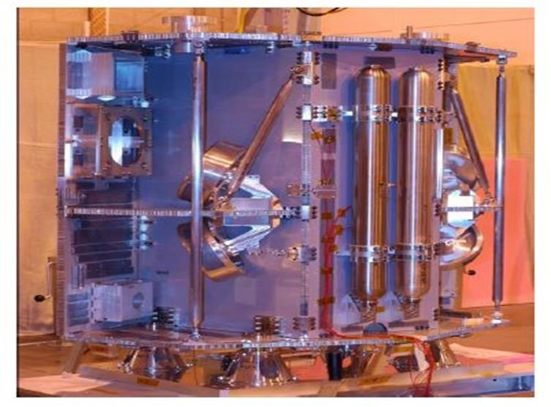

## Figure 2.5: NigeriaSat-2 Carrying Craft

### 2.3.4 NigeriaSat-X

Nigeria Sat-X, which was built by Nigerian engineers trained at the same time the Sat2 was being built as a demonstration that Nigeria can build and launch its satellite was launched alongside NigeriaSat-2. The Two Nigerian-built satellites, NigeriaSat-2 and NigeriaSat-X, were launched in Russia.

The satellite is the result of a transfer training agreement between Nigeria's National Space Research and Development Agency (NASRDA) and Surrey Satellite Technology Ltd, a satellite developer based in the United Kingdom. It brought 26 young scientists from NASRDA to work on the satellite for 18 months, under the supervision of experts in Surrey. NigeriaSat-X will be used for resource management, and for mapping of the country that will feed into food security through crop monitoring, urban planning and disaster management. It will also facilitate the development of Nigeria's space capability and engineering skills for new technologies.

Its 25-year space mission roadmap, approved by the government in 2006, aims to produce a Nigerian astronaut by 2015; launch a satellite built in Nigeria between 2018 and 2030; and be part of the moon mission by 2030.

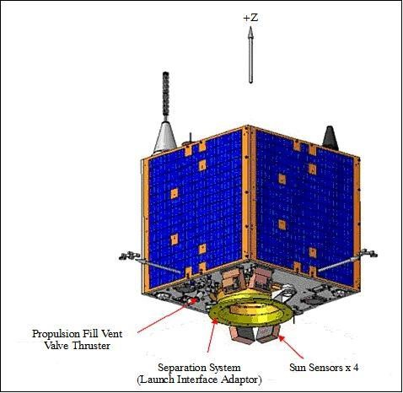

## Figure 2.6: NigeriaSat-X

**CHAPTER THREE**

### 3.0 Relevance of remote sensing and GIS in Urban Mapping

The introduction of GIS and Remote Sensing in the field of urban mapping has been a ground breaking innovation as it has helped to carryout research and better understanding of the earth in relation to planning. With the help of satellite images, GIS and Remote Sensing software has made it possible to help planners analyse problems more quickly and thoroughly, formulate solutions and monitor progress towards long term goals. Research has been made easier as one can view the earth in 2D or 3D and feature can easily be observed and analysed.

### 3.1 Remote Sensing

Remote sensing can be broadly defined as the collection and interpretation of information about an object, area, or event without being in physical contact with the object. Aircraft and satellites are the common platforms for remote sensing of the earth and its natural resources. Aerial photography in the visible portion of the electromagnetic wavelength was the original form of remote sensing but technological developments has enabled the acquisition of information at other wavelength including near infrared, thermal infrared and microwave.

Collection of information over a large number of wavelength bands is referred to as multispectral or hyper spectral data. The development of manned and unmanned satellites has enhanced the collection of remotely sensed data and offers an inexpensive way to obtain information over large areas. The capacity of remote sensing to identify and monitor land surfaces and environmental conditions has expanded greatly over the last few years and remotely sensed data will be an essential tool in natural resources management.

### 3.2 Geographical Information System (GIS)

The geographic information system is a system designed to capture, store, manipulate, analyse, manage and present all types of spatial data or geographic data. In general sense, the term describes any information system that integrates, stores, edits, analyses, shares and displays geographic information. GIS applications are tools that allow users to create interactive queries, analyse spatial information, edit data in maps and present the result of all the operations.

A system for capturing, storing, checking, integrating, manipulating, analysing and displaying data which are spatially referenced to the Earth. This is normally considered to involve a spatially referenced computer database and appropriate application software (Charley Report, 1987).

**3.3 GIS in Urban Mapping.**

Planners use geographic information system (GIS) technology to research, develop, implement and monitor the progress of their plans. GIS provides planners, surveyors and engineers with the tool they need to design and map their neighbourhood and cities. Planners have the fiscal understanding to transform a vision of tomorrow into a strategic action plan for today and they use GIS facilitate the decision making process. By integrating and organizing information spatially, planners can get a broad view of the current situation and more accurately access the future. GIS software can analyse more scenarios more quickly, giving decision makers a choice.

**3.4 Remote Sensing in Urban Mapping.**

Remote Sensing from satellite continues to have a very large impact on the activities of urban planning and continues to provide very great benefits. Remote Sensing techniques provide accurate, orderly and reliable information for planning and management of a town or city. Remote Sensing is extremely useful for change detection analysis, analysing land use - land cover and selection of sites for specific facilities. By satellite images, data is created to analyse and compare things like vegetation rates, erosion, pollution, forestry, weather and land use. These things can be mapped, imaged, tracked and observed.

## 3.5 OVERVIEW OF POTENTIAL AREAS OF REMOTE SENSING AND GIS DATA UTILIZATION IN NIGERIA

### 1. Disaster Management

. Documents pre, on-time and post (flooding) events with possibility for early warning, planning, evacuation, refugee displacement location and relief management. Cultural habits of the affected people and human activities in the immediate and distant environment.

. Associated natural phenomena.

. Total potential area or spread and damages.

. Appropriate planning and management to avoid occurrence or re-occurrence of disasters such as:

1. Lake and river flooding (including reservoir).
2. Coastal erosion and flooding and marine pollution of fresh water Oil pollution

(licks, slicks, spills, etc.) in the Niger Delta and associated environmental degradation. iii. Wind erosion and sand dunes migration. iv. Desertification.

1. Gully erosion.
2. Forest fire or any major fire outbreak. vii. Deforestation.

### 2. Agriculture

. Mapping land use planning and management e.g. Flood plains suitable for rice cultivation.

. Crop inventory and crop yield forecasting.

.Vegetation inventory/revision, planning and management including sustainable forest logging, grazing and planning afforestation programmes.

. Mapping, investigating and monitoring pest infestation including desert locust and quell birds risks.

. Mapping, investigating or monitoring distressed crop areas.

. Crop performance monitoring.

### 3. Water Resources Development and Management

. Surface hydrology and watershed management including analysis of major drainage basins.

. Location of dams or planning water impoundment for various uses: irrigation, domestic, industrial, Navigation, fishery, recreation, hydroelectric power, etc.

. Structural analysis for aquifers springs and borehole location in the preparation of water resources master plan.

### 4. Solid Mineral Exploration/Exploitation

. General geological mapping and map update/revision.

. Planning solid mineral exploitation including mine reclamation.

. Structural, including lineaments, analysis and regional geological reconstruction and mineral exploration.

. Mapping/differentiation of host mineralized zones and rocks in oil/gas and solid mineral exploration in the preparation of geomorphologic maps.

### 5. Ecosystems Management with Associated Goods and Services

. Mapping/differentiation of friendly/economic floral or plant species and fauna or wildlife habitats (e.g. Forest and games reserves)

. Forest and rangeland monitoring

. Pollution of marine ecosystem due to effluents from domestic and industrial wastes

. Planning protection and management of lakes, reefs and mangrove ecosystems

. Mapping and monitoring wild aquatic plants e.g. Water hyacinth

. Local and regional planning for tourism and tourism potentials as well as investigation of historical/archaeological sites.

### 6. Demographic and Cadastral

. Mapping/planning population survey and census enumeration areas.

. Rural and urban growth mapping and monitoring.

. Monitoring land/use/cover dynamics.

### 7. Transportation and Utilities

. Terrain evaluation for various uses and regional planning.

. Route location and road allocation planning with road maintenance strategy.

. Planning economic railway network development.

. Mapping and planning utilities location: Oil pipeline, Power Holding Company of Nigeria (PHCN) transmission line, NITEL cables and telecommunication network.

. Planning waterways and general land and water transportation network.

### 8. Environmental Management

. Mapping/planning sewage location and domestic/industrial waste disposal sites.

. Mapping/monitoring soil and land degradation.

. In the determination of environmental impact assessment.

. Risk zone mapping and environmental inventory and monitoring.

### 9. Defence and Security

. Mapping of state and international boundaries.

. In the mapping/planning terrain traffic ability for movement of ground troops and military wares.

. Provision of maps/geo-information for vehicle tracking.

. Mapping/determination of camouflages.

. Bathymetric mapping of the coastal areas for surveillance purposes.

### 10. Health and Public Health Delivery

. In malaria epidemiology study of the relationship between malaria vectors and environmental variables (larvae habitats) e.g.

1. Flooded pastures and transitional swamps and other breeding sites and plants.
2. Combine with weather data for delineating harmattan dust area with associated diseases.
3. In remote sensing and GIS for meningitis early warning and prevention and isolation of river blindness environment.

## CHAPTER FOUR 4.0 DISCUSSION AND ANALYSIS OF EXPERIENCE ACQUIRED DURING MY SIWES PROGRAMME

The National Space Research and Development Agency is a part of the ministry of science and technology which deals in its core on applications of remote sensing technology and Geographic Information Sciences in space studies. The agency is well known for her advanced knowledge and use of remote sensed data and GIS to carryout research.

During my SIWES period at the National Space Research and Development Agency (NASRDA), I was opportune to gain a wide level of exposure to a good number of well recommended GIS and Remote sensing application software’s and also learnt how to download satellite images using their paths and rows from the web. These software’s are the main tools used in the department of Strategic Space Applications to carry out projects and research. These software’s include;

ArcGIS 10.0, 10.2, 10.3, 10.4, 10.5

ERDAS IMAGINE 2014

GOOGLE EARTH PRO

ENVI RS SOFTWARE

### 4.1 ArcGIS 10.5

ArcGIS is a geographic information system (GIS) for working with maps and geographic information. It can be used to make, use and share maps. It can also be used for compiling geographic data; analysing mapped information; sharing and discovering geographic information; using maps and geographic information in a range of applications; and managing geographic information in a database.

With the use of this software I learnt how to:

• Create of geo-data base: Geo-data base is an object based vector data model which serves as a container that stores data about a location. There are two types of geo-data base.

1. Personal geo-data base: this stores data set in a folder that is limited to the size of 2gigabytes
2. File geo-data base: stores data set in a folder that can be up to the size of 1terabyte

* Geo-reference a map: this involves assigning real world coordinates to a number of reference points on the image.
* Digitize a map: this is the extraction of features from a map to create a new map having only the required features needed.
* Data exploration and manipulation: converting attribute table from ArcMap10.5 to Microsoft Excel format and then importing the table back to ArcMap10.5
* Map projection: is a systematic transformation of geographic coordinates into a projected coordinate on a flat surface upon which features from the curved surface of the earth may be mapped.
* Interpolation: This is the technique that enables acquisition of values or points for areas that have no values or points.
* Buffering: is used to determine the area covered within a specific location measured in units of distance and time.
* Create a Digital elevation model: to show a 3D view or representation of a terrain surface
* Clipping and Modelling: this enables cutting out a small area from a large map so as to narrow down to only the areas needed to work on and it can also be used to calculate cell statistics for a raster image.
* Masking data to the size of a map
* Prediction of vegetation or crop yields and also monitor the health condition
* Band combination to get a clearer picture of a satellite image for identification or features on the image.
* Mapping land surface temperature to check the heat intensity generated by the activities of the population of that area.
* Noise mapping and cancellation using sound meter to check the level of noise generated by the activities of population at a particular area.
* Map embellishment: Is the beautification of a map to give/interpret information’s on it
* Creating a study area map for research purposes and inputting features like title, legends, north- arrow, scale bar and grids.
* Flood and hazard prediction using Multi Criteria Analysis.

## 4.2 ERDAS IMAGINE 2014

ERDAS Imagine is a remote sensing application with raster graphics editor abilities designed by ERDAS for geospatial applications. Imagine is aimed mainly at geospatial raster data processing and allows users to prepare, display and enhance digital images for mapping used in geographic information system (GIS) and computer-aided design (CAD) software. It is a toolbox allowing the user to perform numerous operations on an image and generate an answer to specific geographical questions.

By manipulating imagery data values and positions, it is possible to see features that would not normally be visible and to locate geo-positions of features that would otherwise be graphical. The level of brightness, or reflectance of light from the surfaces in the image can be helpful with vegetation analysis, prospecting for minerals etc. Other usage examples include linear feature extraction, generation of processing work flows (spatial models in Imagine), import/export of data for a wide variety of formats, orthorectification, mosaicking of imagery, stereo and automatic feature extraction of map data from imagery.

With the use of ERDAS IMAGINE I learnt how to:

* Layer-stacking: is the combination of bands to get a clearer picture of a satellite image for identification of features on the image.
* Sub-setting: is inputting a vector shape file on the image and then clipping out an area from the whole image.
* Supervised classification: this is the process having knowledge about the areas on the satellite image and classifying the image.
* Unsupervised classification: this is the process of classifying an image without having any knowledge about the areas on the satellite image.
* Change detection: for identifying changes on satellite imagery for different years.
* Land use/ land cover map generation for research purposes
* Satellite image correction

## 4.3 GOOGLE EARTH

It is a visual and geographic information program. It maps the earth by super imposition of images obtained from satellite imagery, aerial photography and GIS onto a 3D globe. Google earth displays satellite images of varying resolution of the earth’s surface, allowing users to see things like cities and houses looking perpendicularly down or at an oblique angle. Google earth image at a high resolution can be substituted for quick-bird images. This software makes it easy to get the exact longitude and latitude of a place.

## 4.4 ENVI

It is an integrated GIS and remote sensing software solution. It’s an easy to use software tool with a friendly interface that enables the user to simply process images with nearly 300 modules for the analysis and display of digital spatial information. It enables researchers to analyse earth system dynamics for effective and responsible decision making for environmental management, sustainable resource development and equitable resource allocation.

With the use of ENVI one can learn:

* Band combination
* Supervised/ unsupervised classification,
* Change detection
* Land use/ land cover map generation,

I was also fortunate to get involved in a few number of projects carried out at the agency. The projects include;

* Noise mapping of NARSDA.
* Population and Census data estimation for Nigeria.
* Land use/cover mapping of Abuja Municipal.

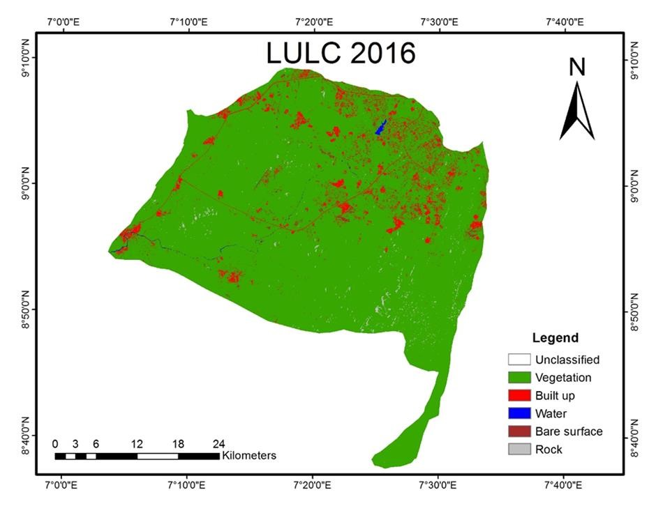

Figure 4.0: Land use/Land cover map of Abuja Amac 2016

From the above map, land use was classified into five (5) classes which are vegetation, Built up area, bare surface, water and rocks using ERDAS IMAGINE 2014 software.

|  |  |  |
| --- | --- | --- |
| CLASS | AREA_2016 | % |
| BUILT UP | 9806.01292 | 6.199745262 |
| VEGETATION | 145972.472 | 92.28951139 |
| ROCK | 978.61712 | 0.618720055 |
| WATER | 294.502362 | 0.186195923 |
| BARE SURFACE | 1116.39301 | 0.705827367 |
| TOTAL | 158167.997 |  |

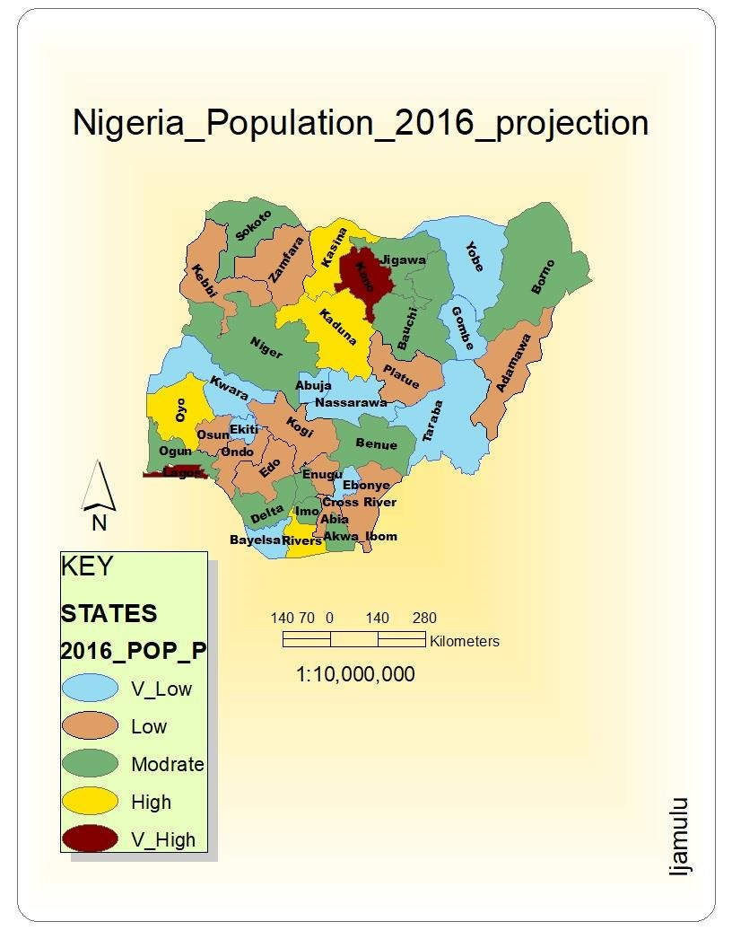

Figure 4.1: population density map of Nigeria showing the rate of males and females, using ArcMap 10.5.

**CHAPTER FIVE**

## 5.0 CONCLUSION

The six months Student Industrial Work Experience Scheme afforded me the opportunity to have knowledge of different remote sensing and GIS software’s, and their applications to Geography as well as Regional Planning, which is my course of study. I gained more experience in the use of GIS software like ArcGIS in analysing Land use/Land cover changes in a geographical area which directly and indirectly have effect on the climate of a particular area and also how to carryout Interpolation using Inverse Distance Weighted (IDW) and Kriging’s method. This training experiencing apart from getting me familiar to GIS and Remote sensing has also help me in my presentation skill and creation of power point lectures. Aside gathering experience, I have been able to work successfully with people from different background, hence, improving my team spirit.

Also, the use of the software’s exposed me to a whole new way of how to conduct research in my field of study.

Looking at the aims and objectives of the programme alongside all I learnt, I can convincingly say that the programme remains unbeatable. I can also say that having this experience in NASRDA - Abuja (Centre for Space Application), there has been positive impact on my view towards Geography as a profession.

I can say without doubt that the experience has been rewarding as this report reveals most of the work experience I had, hence, justifying the importance of SIWES.

## 5.1 RECOMMENDATION

Though I gained a lot of experience during the training period, some measures still need to be put in place to achieve greater success and help those who will undergo SIWES in the future.

The government should see to it that the programme is taken seriously. To achieve this, the ITF staffs should be mandated to visit the students on training. This will go a long way in solving whatever challenge the student might be facing in his or her place of attachment. The government should see to it that more rooms are provided in public offices to accommodate Industrial Training students. The industry/organization where students are attached should be encouraged to pay stipends to the students as this will go a long way in motivating the students as a lot of students are faced with lots of financial issues and the present economic situation is not helping matters. Also, students should be regularly monitored during their period of attachment. Students should also see the period of their attachment as a time to attend conferences, meetings and seminars related to their field of study.

Stability in power supply is also very important in the training process as during my internship it was one of the major setbacks I faced as without light, no lectures would be taught and we cannot carry out any work once our systems are down as there was no standby generator (leister generator). It’s in my opinion that a standby generator is a must in Government agencies as this will go a long way to increase their efficiency in their projects and make them deliver on time.

Students should cease this opportunity to improve on themselves and GIS and Remote sensing should be taught intensively in Geography and Meteorology and other

Environmental Science related courses as it’s a basic and important tool in their field of study.

## REFERENCES

* Ralph N. Agwuna (2012): ‘Detailed Manual on SIWES Guidelines and

Operations for Tertiary Institutions’. Rex Charles & Patrick Limited, Anambra.

Pg. 1-6.

* Bankole, Oni (1996): “The Role of ITF in Human Resources Development in

Nigeria’.

* Akere Jola, .O. (2008). Information and guidelines for students industrial work experience scheme.
* IPA (1979): ‘The Master Plan for Abuja, the new Federal Capital City of

Nigeria’. Prepared by the International Planning Associates.

* Campbell, J.B. (1987) ‘Introduction to Remote Sensing’. The Guilford Press, New York.
* www.researchgate.net.
* Lillesand, T.M. and Kiefer, R.W. (1994) ‘Remote Sensing and Image Interpretation’. John Wiley and Sons Inc., New York.
* Russ, John C. (1995) ‘The Image Processing Handbook’. 2nd edition. CRC Press, Boca Raton.
* ‘Fundamental of Remote Sensing’ by Canada Centre for Remote Sensing.
* Burrough, P.A. (1986) ‘Principles of Geographical Information System for land

Resources Assessment’. Monographs on soil and Resources Survey. Clarendon Press, Oxford, U.K.

* Gem, G. J. Application of Remote Sensing and GIS in urban planning
* Mahesh Jhawar, N. T. (2017). URBAN PLANNING USING REMOTE SENSING. *International Journal of Innovative Research in Science, Engineering and Technology*.